Newsletter
Updated: 11/21/2020, 09/08/2025
Job or Activity: Newsletter Editor | Person Responsible: Jamethiel Morse newsletter@pner.net
Elected or Appointed? appt | When? January 2025
Specific Qualifications? yes | If so, what are they? Helpful to have word processing or publishing skills
If this is a committee, list other members
Other positions interface with this one. | Membership Secretary supplies monthly membership information for newsletter distribution.  Points Secretary for monthly reporting of ride results and award standings. Ride results available on the website.  Secretary is responsible to send BOD meeting announcements 30-45 days in advance for publication. Send minutes of each BOD meeting for publication.  President reports any Executive Committee actions for publication. President may send in a monthly column for the newsletter.  Handbook Editor will supply a list of paid ride flyers each year. See note – no charge currently
By-laws Description: | Section 6. Points Secretary. It is the duty and responsibility of the Points Secretary to record and maintain clear and accurate records of the points and miles for all ride results from all recognized events that are received; to return ride results to the ride manager for necessary correction of results; and to supply the standings for PNER year-end awards for publication in the PNER Newsletter.  Section 5. Board of Directors Meetings.  - Notice of Meetings. Notification of all Board meetings shall be made to the general membership in writing, at least thirty days, and not more than forty-five days, prior to the date of the Board meeting. ........ Actions of the Board of Directors at regular, executive session and special meetings shall be reported to the general membership in the newsletter and at the following Annual Meeting.
Expected monthly time commitment: | 8-14 hours
Basic Responsibilities:
1. Submission deadline is the 20th of each month. 10th and 15th of every month – send an email to all contributors giving them a heads up and reminding them of the 20th deadline. Post on Facebook and Yahoo site Need to clarify with the BOD how often the newsletter needs to go out.

2. 20th of every month—receive contributions and edit/layout into the newsletter: Essentials:
- -President’s Paddock and VP Corner (receive from pres and VP)
- Request Ride Results from the Points Sec every month (need to have access to the dropbox).
No longer in Newsletter. Refer to website.
- -Standings from the Points Secretary. Include the standings every month. You'd be surprised how many people just like seeing their name in print. You are only required to print the number indicated for each award, but including beyond the award number is acceptable. The handbook lists the number for each award. Include a box to remind people the whole list is online. In October and November, try to print the entire list for all awards, so any corrections come to light before awards are purchased.
- -Board of directors, officers and appointed positions list with contact info listed every month.
- -Half page ride fliers (receive from RMs— ask Handbook Editor, who sometimes gets them. Keep track of who paid (from Handbook person) and make sure to request any missing ones as they came up the month prior to that ride. Not currently doing half page flyers. Insert ride flyers for the next 2 months. No charge now. 2027 RMs will need to be PNER members for their ride flyers to be advertised.

3. We currently don’t have advertisements/classifieds in the newsletter. This could change. Use excel spreadsheet to keep track of ads and how many months they will run. Advertisements and classified (Receive directly from advertisers or from convention volunteers during convention time.) Rates are posted online and in every newsletter. Let advertisers know when they need to renew their ad. Pay for 3 months in advance and get one month free.

4. Additional:
-Member stories and photos
-Announcements and news
-Ride cancelations or date changes
-PNER Scholarship essays

5. Assembly:
- Assembling the newsletter typically takes a few hours spread out over a week or so. There is no newsletter in February because Jan. 20 deadline is too close to convention.
- Editing options:
- LucidPress
- Microsoft Publisher with the results and standings in excel tables.
- Adobe InDesign for everything.
- Once you’ve built your first issue, it’s pretty easy to keep plugging stuff into the same layout over and over. InDesign makes plugging stuff in very easy
- For photos, make sure and credit the photographer. If a picture was taken by a professional, the person who sent it to you must have their permission.

5.. Once formatted, if not using LucidPress, convert to PDF For electronic, make two PDFs. The first one is “High-Quality Print” in the PDF settings and the other one is “Interactive.” The interactive one turns the web addresses into links.

6. MailChimp account for sending - User: pnernewsletter password: pNER1$k00L

Adding Members to the Email List
- Log into MailChimp with the appropriate account (for the newsletter use pnernewsletter).
- Select Lists from the top navigation bar:
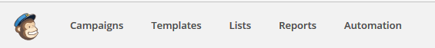
- Find the list you would like to add the person to and select the Add Subscriber button on the right side.
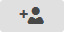
- A form will open below the list line. Fill out the relevant fields and click the top box that says the person gave you permission.
- Click Subscribe
- The form will stay open if you have more people to enter, otherwise click cancel.

Creating a Mailing Campaign
When you send a newsletter type item through MailChimp you do it with what is called a campaign.
- When you first log in you are brought to a dashboard that shows recent campaigns. To create a new one click on the down arrow on the gray button located on the right side to select “Regular Campaign”
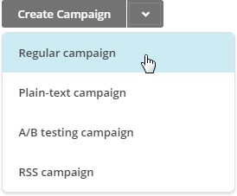
Membership will keep the email list, PNER Newsletter, up-to-date. Select that list and the default selection of Send to Entire List. Click ‘Next’ in the bottom right.

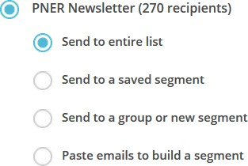

- For the Campaign Info, you’ll need to fill in the top four boxes, but other than that the default selections are all fine. Below is an example of those four fields, feel free to adjust as needed. Click ‘Next’ in the bottom right to continue.
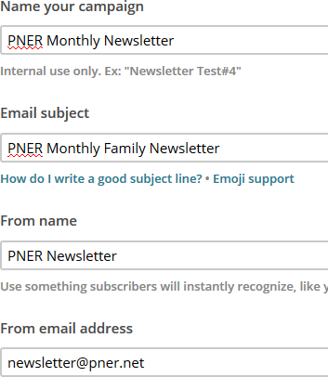
- How creative do you feel? This next page allows you to create an email from scratch, use a theme or a previously used template. Continuity is probably a good thing in this design, so for these directions I’m selecting the Saved Templates tab and the template displayed below. This
template should always show up under this tab and with minor edits as shown in the next step. Note the Last edited date to remember which one you used last time. Click Selected and it should take you to the Edit page.
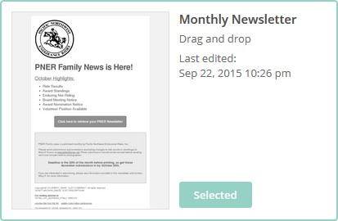
- The next page is where you can edit the email that will be sent out. The left side is what it looks like in real time and the right side of the screen is for editing the fields in the email. Look for the pencil icon when you hover over areas of the email. Click that to be able to edit the fields.
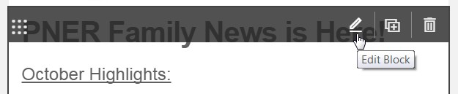

- The important part is to change the gray box link to the newest version of the pdf newsletter.

  - Click the Edit pencil and a screen will open up on the right side.
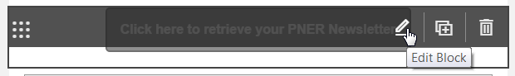
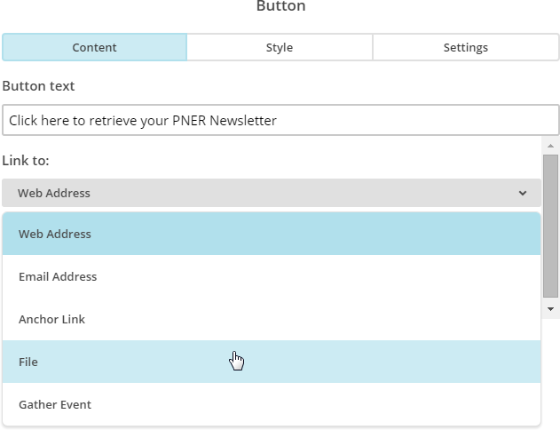
  - Change Link to: to File and you will be taken to the File Manager page.
  - Click the Upload button in the upper right
  - This will open up a File Upload window, find the newsletter file pdf, highlight it and click Open. When you save the newsletter file as a pdf after creating it, try to add the month and year to the file so it stays somewhat organized in Mailchimp.
  - When the upload is complete it will take you back to the previous screen.
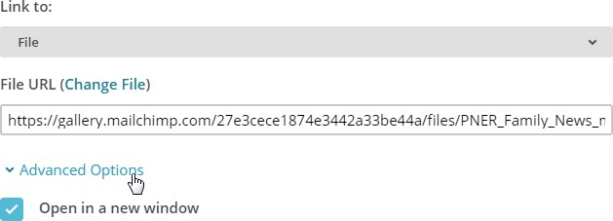
  - Under Advanced Options, make sure the box is checked to Open in a New Window.
  - Click Save & Close at the bottom.

- When you are satisfied with the text and you have definitely done step 6, click Next in the bottom right to come to a summary screen. Check and make sure that it looks okay, but don’t fret too much about these details.
- You now have two options in the bottom right. You can send immediately or you can schedule to send.
  - Schedule: Select a date to send (last day of the month, or first day of the next month) and a time to send. The other features you have to pay for, so don’t get fancy.
    - Click Schedule and you are all set.

